Steve Kepler
SDEV 220 – Module 5 Assignment – Testing
29 March 29, 2026

Unittest Output
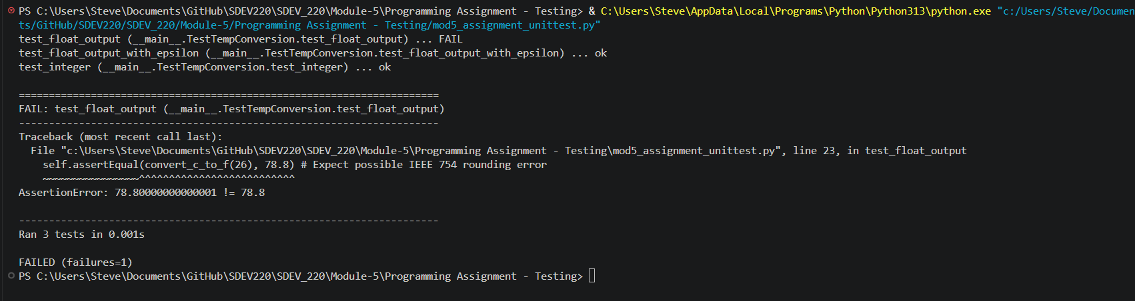
Pytest Output
